# Test Plan

**MediCare**

1. **Database Testing**

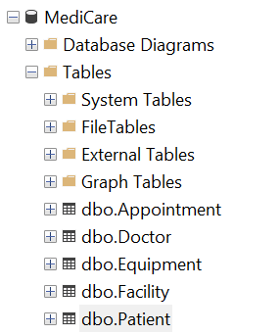

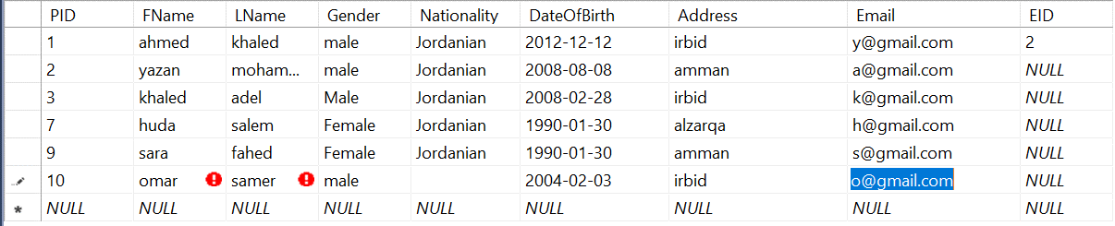

**• If the member does not fill the nationality, it is filled with "Jordanian" by default.**

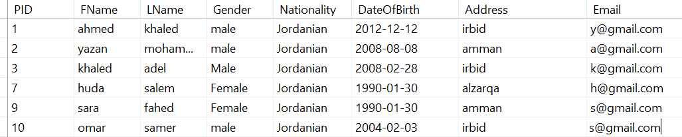

**• Not to register any two customers with the same email.**

**• Requires a password for security.**

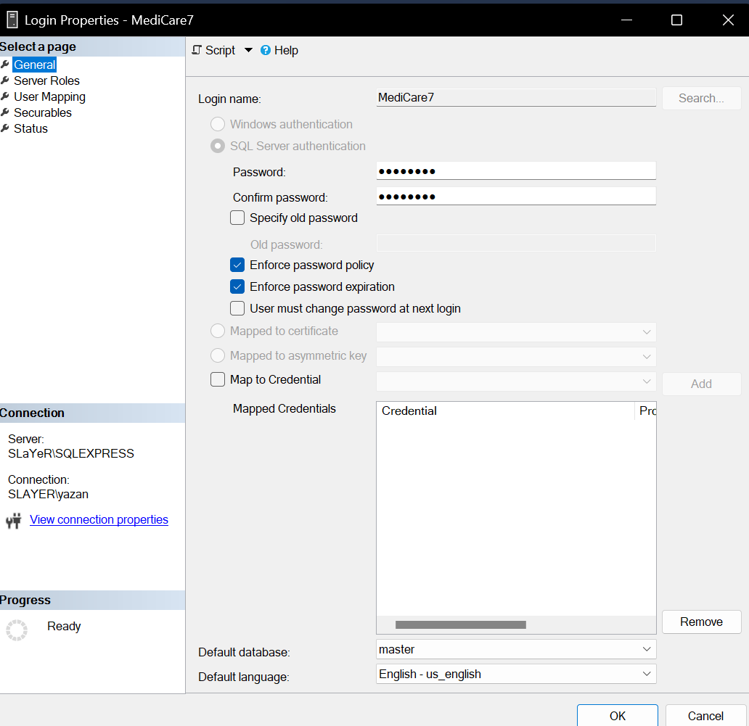

**• Requires a backup.**

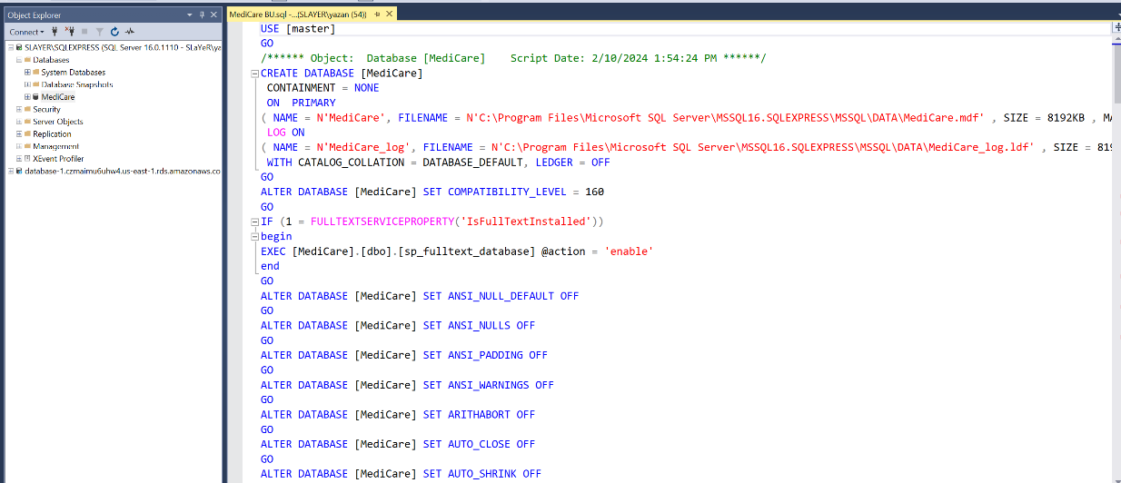

1. **Functional Testing**

**User Requirements:**

**The possibility of registering patients for an account with unique identifiers (email, password) to access the system.**

**A secure login process that ensures confidentiality and data security.**

**The ability to update and manage personal information (name, contact details, address, nationality, date of birth) of patients.**

**before**

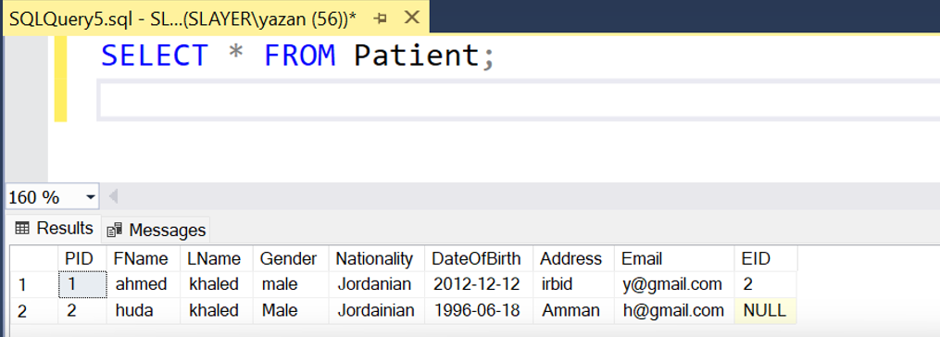

**Go away**

**The ability to book a facility for specific medical purposes.**



**Patients' ability to use and reserve specific equipment and access information about available medical equipment.**





**Ensure that personal data is secure and not accessible to unauthorized individuals**

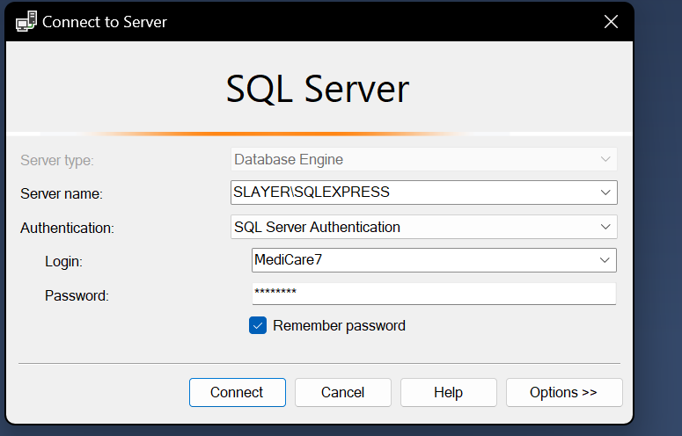

**Confirm data backups for reliability**

**System Requirements:**

**Secure login system with encrypted password storage**

**A centralized database to store patient information, doctor details, nurse and staff details, facility information, and equipment data.**



**Unique identifiers (IDs) for patients, doctors, facilities and equipment for efficient data retrieval**

**Validations to ensure data integrity for example, unique email constraint, mandatory fields.**

**Regular and automated data backup to prevent data loss in case of system failure or data corruption.**

**System logic to ensure that the default values of the nationality "Jordanian" are set when the necessary data is not provided**

1. **Cloud Database System Testing**

**Configuration**

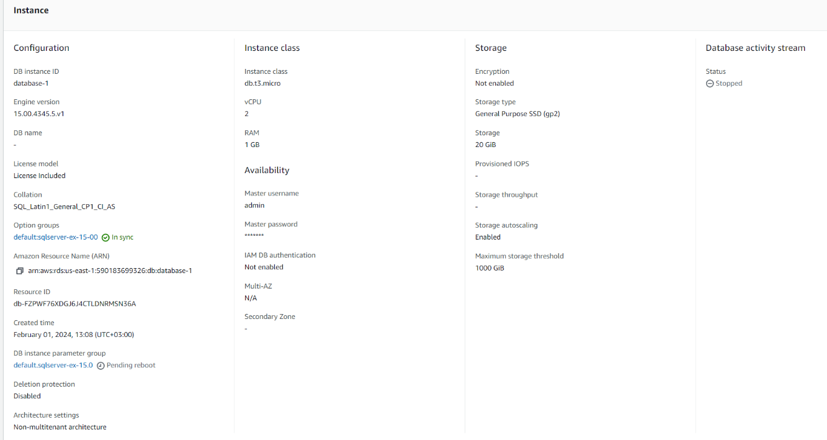

**Back up every week**

**CloudWatch to ensure everything is doing good.**

**System Notes**

**Security**

Virtual Private Cloud (VPC): The database resides within the finely configured AWS Virtual Private Cloud (VPC). This strategic decision ensures that the database is protected within a private network, limiting access to it exclusively on authorized entities. VPC setup acts as a secure area, protecting sensitive healthcare data from unauthorized access.

